**“CS5785 Homework 3”**

**Submitted as part of Homework**

**required for**

**Applied Machine Learning (CS5785)**

**SUBMITTED BY**

TANUJ AHUJA – ta364

JAMIE YU – jky32

**SUBMITTED TO**

***Cornell Tech, Cornell University***

**2 W Loop Road,**

**New York, NY 10044**



**PROGRAMMING EXCERCISES**

**Q1.** **Sentiment analysis of online reviews.**

In this assignment, you will use several machine learning techniques from the class to identify and extract subjective information in online reviews. Specifically, the task for this assignment is **sentiment analysis**. According to *Wikipedia*, sentiment analysis aims to determine the attitude of a speaker or a writer with respect to some topic or the overall contextual polarity of a document. It has been shown that people’s attitudes are largely manifested in the language they adopt. This assignment will walk you through the mystery and help you better understand our posts online!

**Important:** Use your own implementations for PCA and bag-of-words. You can rely on libraries for SVD, lemmatization, data reading, and cross validation.

Q**1(a).** Download Sentiment Labelled Sentences Data Set. There are three data files under the root folder. *yelp_labelled.txt*, *amazon_cells_labelled.txt* and *imdb_labelled.txt*. Parse each file with the specifications in *readme.txt*. Are the labels balanced? If not, what’s the ratio between the two labels? Explain how you process these files.

**Ans1(a).** We downloaded the data as required and used the following snippet of code to analyze it.

‘rstrip’ was used to extract lines first and create a list of lines of data and then each line was split at tabs essentially dividing the data into two column format, i.e., REVIEW and SCORE.

Further, it was observed that for all three data sources, count of positive and negative reviews, i.e. scores of 0 and 1 were balanced.

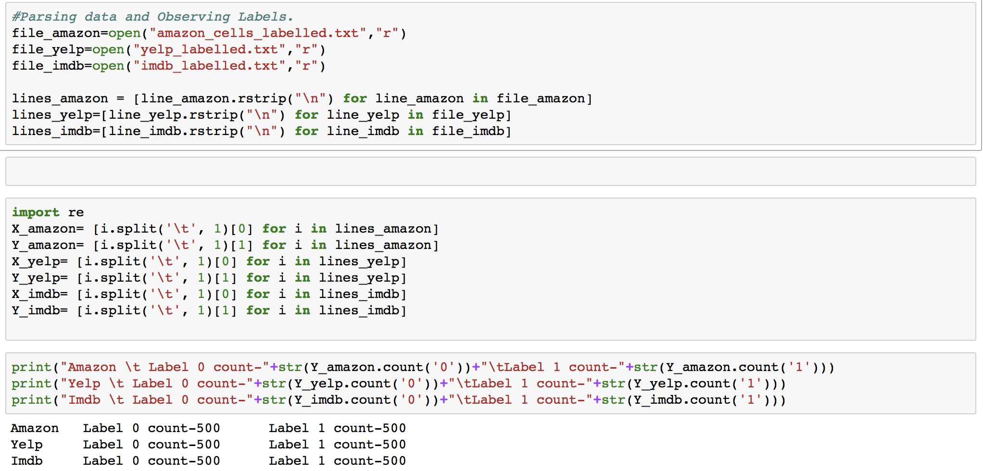

**Q1(b). Pick your preprocessing strategy.** Since these sentences are online reviews, they may con- tain significant amounts of noise and garbage. You **may or may not** want to do one or all of the following. Explain the reasons for each of your decision (**why or why not**).

* + Lower case all of the words.
  + Lemmatization of all the words (i.e.,convert every word to its root so that all of “running,”  “run,” and “runs” are converted to “run” and all of “good,” “well,” “better,” and “best”  are converted to “good”; this is easily done using nltk.stem).
  + Strip punctuation.
  + Strip the stop words, e.g., “the”, “and”, “or”.
  + Something else ? Tell us about it.

**Ans1(b).** 1) The first and simplest processing we applied was converting everything to lower case for obvious reason that we don’t want our bag of words model to be overloaded with similar words written in different cases.

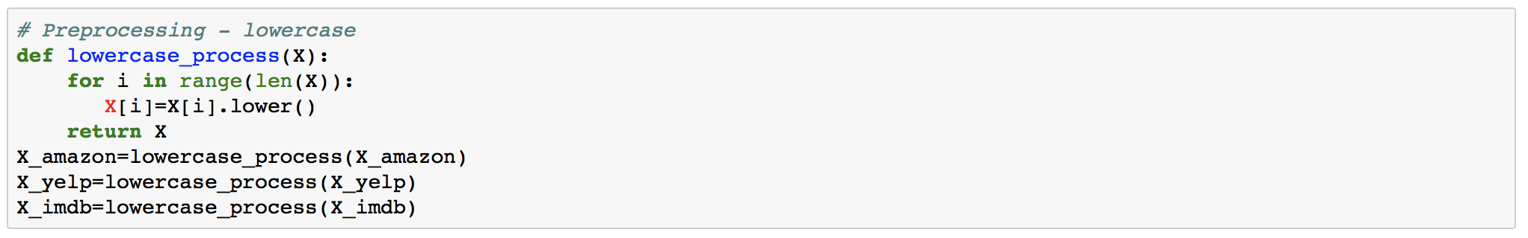

2) Next, we tried to remove all the punctuation symbols such that words like ‘me’ and ‘me.’(the later one being an example of a word at end of line) don’t get counted as different words altogether.

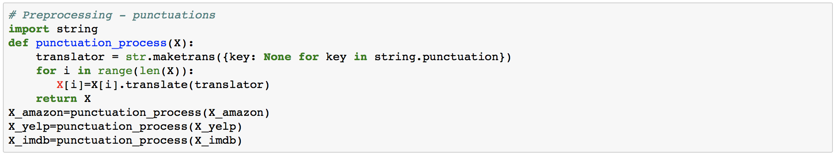

3) Next we removed all the stop words because words like ‘is’, ‘the’, ‘a’, ‘too’ etc. don’t convey any sentiments. To achieve this, we used the inbuilt stop word dictionary provided by NLTK library.

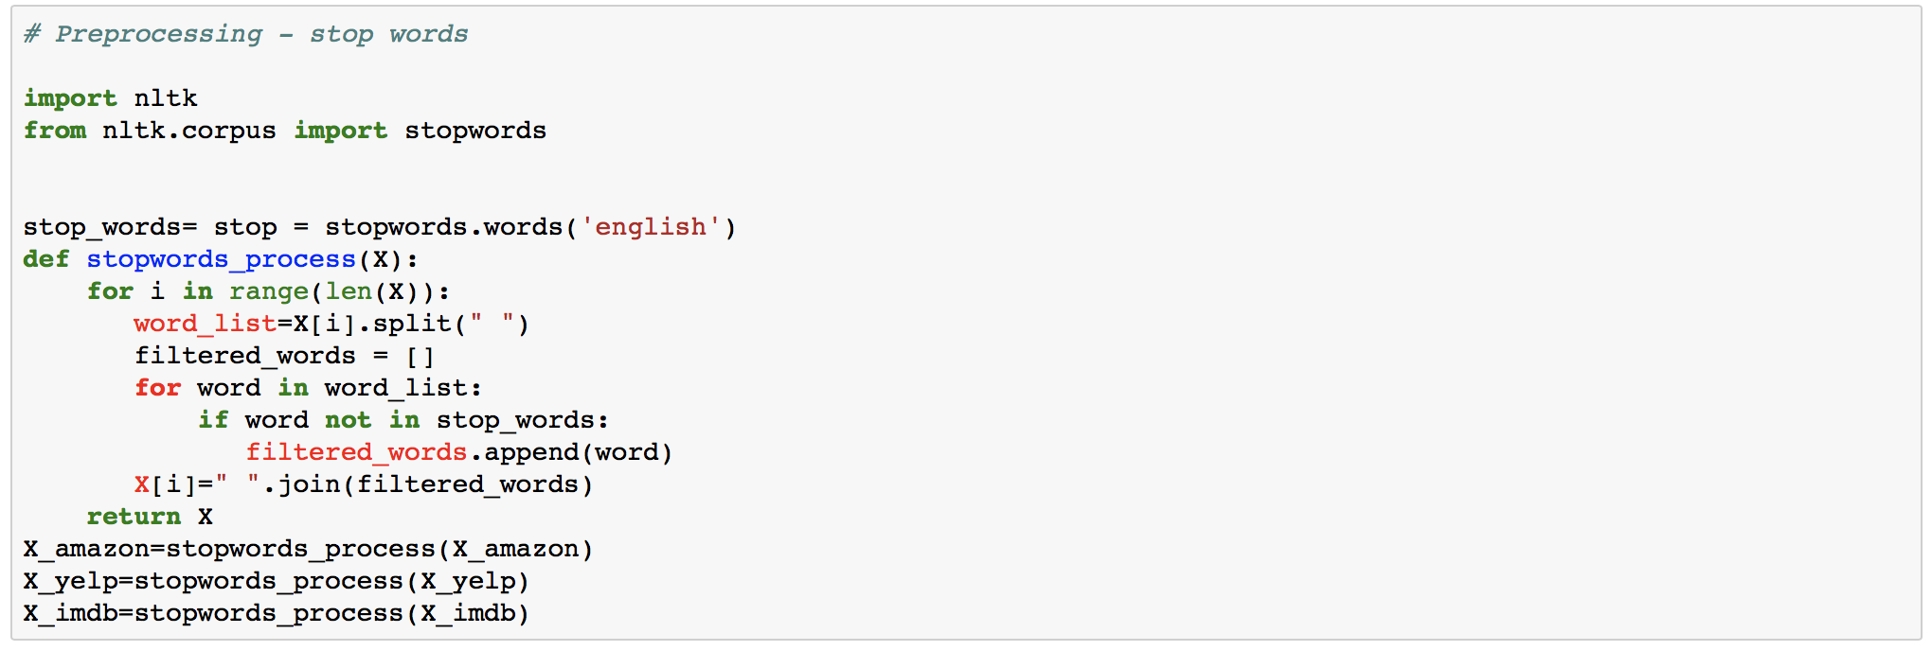

4) Going forward, we found it important to use a STEMMER function so that nouns, verbs, adverbs etc. don’t get counted as different occurrences. Stemming essentially cuts words like ‘seeing’ and ‘seen’ to ‘see’ so that we have a reduced and compact word family representation for everything.

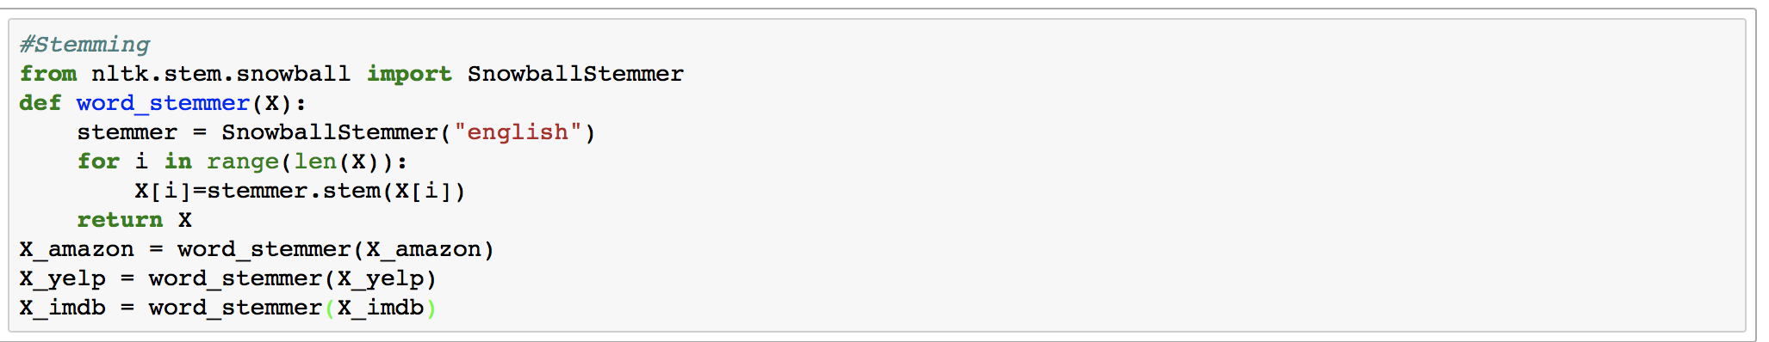

5) Finally we performed Lemmatization so that we intelligently group synonyms into single category (For eg- Good, better,best all are grouped under Good). For this we used an inbuilt tool called *Word Net Lemmatizer.*

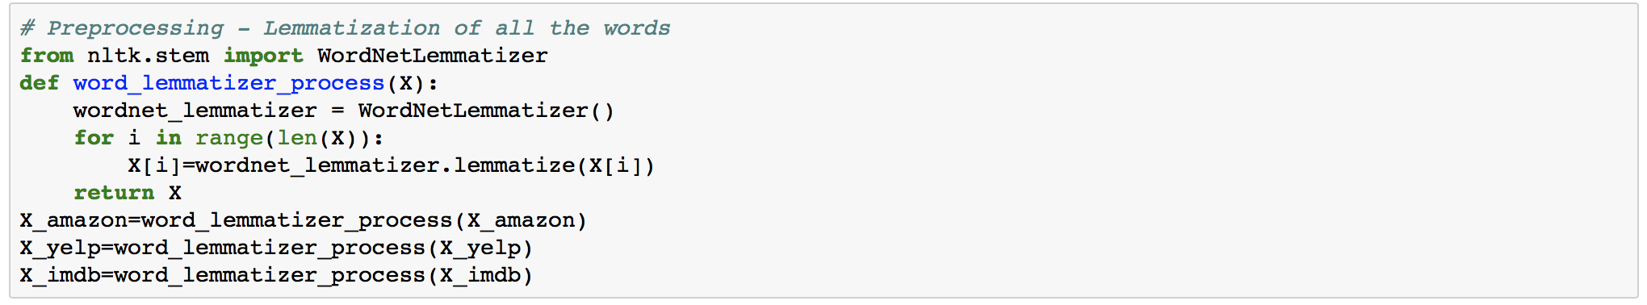

**Q1(c). Split training and testing set.** In this assignment, for each file, please use the first 400 in- stances for each label as the *training set* and the remaining 100 instances as *testing set*. In total, there are 2400 reviews for training and 600 reviews for testing.

**Ans1(c).** We used the following snippet to achieve the data splitting into Training and Testing Data.

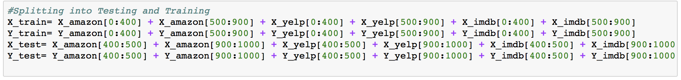

**Q1(d).** **Bag of Words model.** Extract features and then represent each review using bag of words model, i.e., every word in the review becomes its own element in a feature vector. In order to do this, first, make one pass through all the reviews in the *training set* (**Explain why** we can’t use *testing set* at this point) and build a dictionary of unique words. Then, make another pass through the review in both the *training set* and *testing set* and count up the occurrences of each word in your dictionary. The *i*th element of a review’s feature vector is the number of occurrences of the *i* th dictionary word in the review. Implement the bag of words model and report feature vectors of any two reviews in the training set.

**Ans1(d).** We followed the exact steps suggested by the question, that is, firstly we created a dictionary of unique words using only the training data.

Next, we iterated over training and testing data and updated the occurrence of words in the dictionary.

Ultimately, we created a list of feature vectors each having a sparse representation such that only those elements in each column are populated corresponding to which there is occurrence of a word in simultaneous sentence.

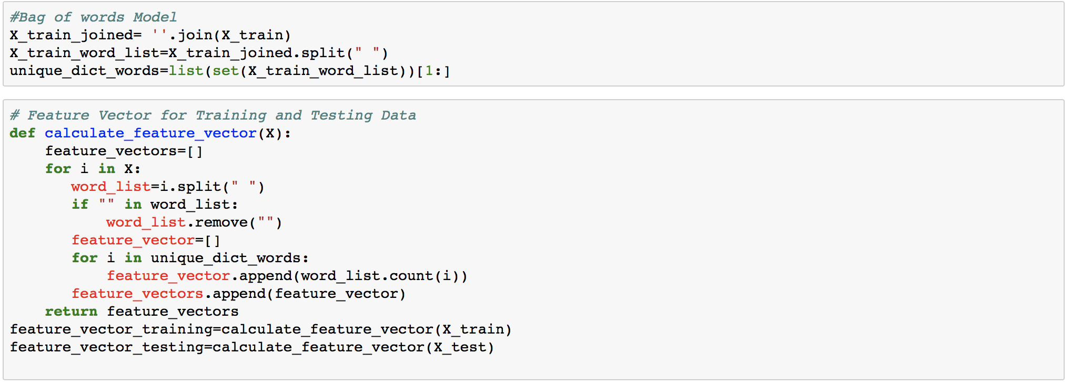

Sparse feature vectors look like:

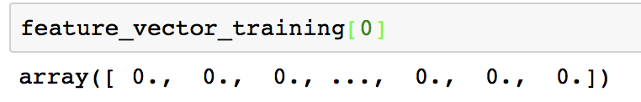

**Q1(e).** **Pick your post processing strategy.** Since the vast majority of English words will not appear in most of the reviews, most of the feature vector elements will be 0. This suggests that we need a post processing or normalization strategy that combats the huge variance of the elements in the feature vector. You may want to use one of the following strategies. Whatever choices you make, explain **why** you made the decision.

* *log-normalization.* For each element of the feature vector *x*, transform it into *f* (*x*) = *log*(*x*+1).
* *l* 1 *normalization.* Normalize the *l* 1 norm of the feature vector, **x**ˆ = **x/ |x|**
* *l* 2 *normalization.* Normalize the *l* 2 norm of the feature vector, **x**ˆ = **x/ ||x||**
* *Standardize* the data by subtracting the mean and dividing by the variance.

**Ans1(e).** Given that the feature vector list is densely sparse in nature, it made sense to apply L2 normalization which is a useful technique to deal with sparseness of data. To achieve this, we used inbuit function provided by scikitlearn library.

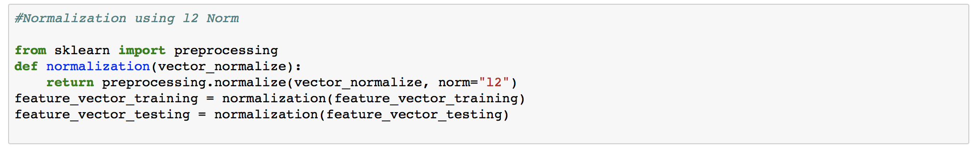

**Q1(f).** **Sentiment prediction.** Train a logistic regression model (*you can use existing packages here*) on the training set and test on the testing set. Report the classification accuracy and confusion matrix. Inspecting the weight vector of the logistic regression, what are the words that play the most important roles in deciding the sentiment of the reviews? Repeat this with a Naive Bayes classifier and compare performance.

**Ans1(f).** The logistic regression and naïve bayes model have been trained and used to predict accuracy over test data.

|  |  |
| --- | --- |
| LOGISTIC REGRESSION | NAÏVE BAYES |
| Accuracy- 0.79 | Accuracy – 0.801 |

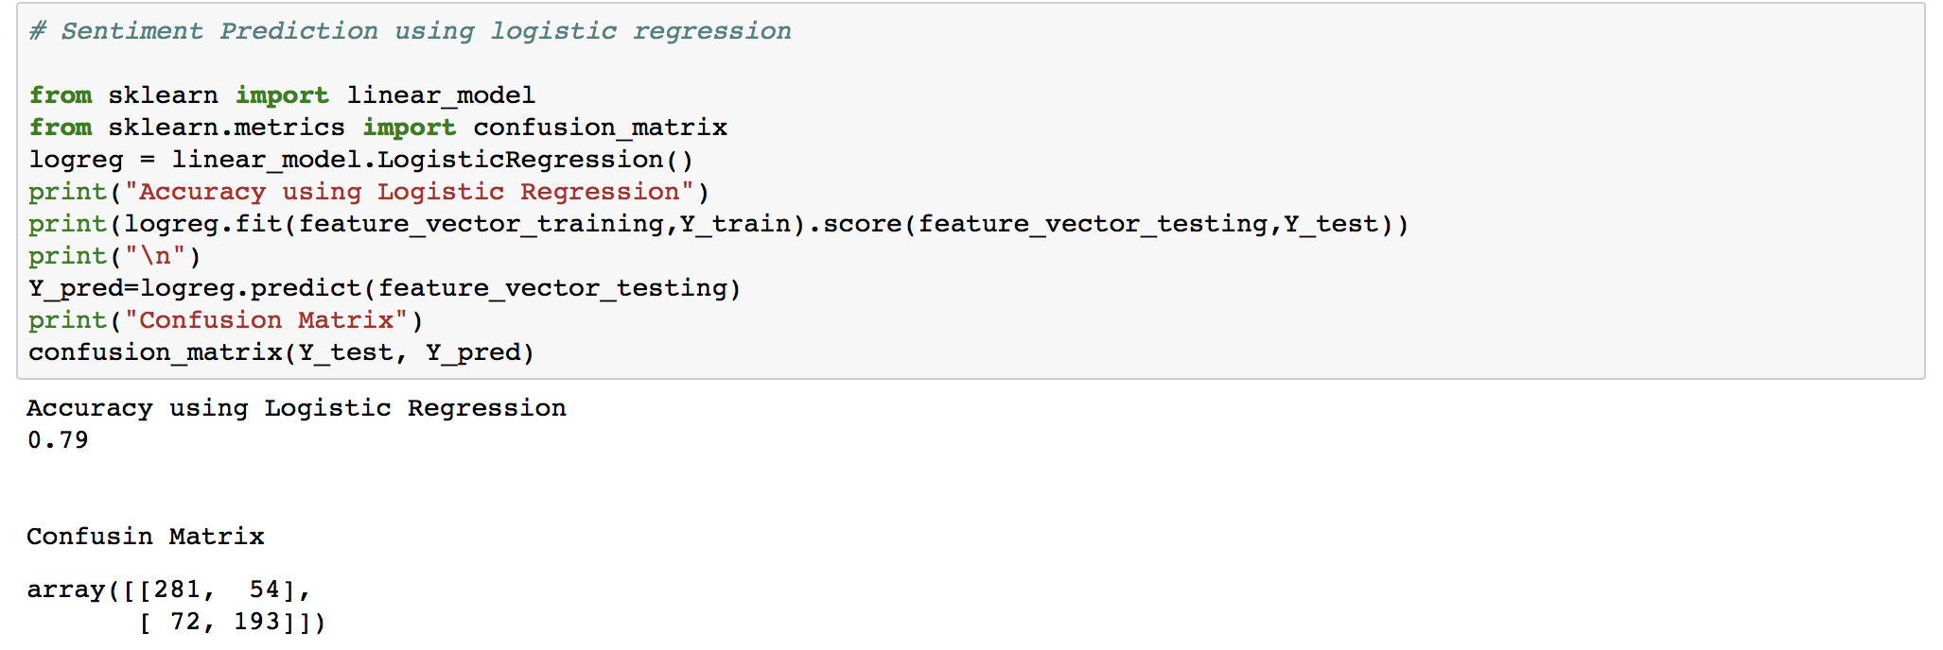

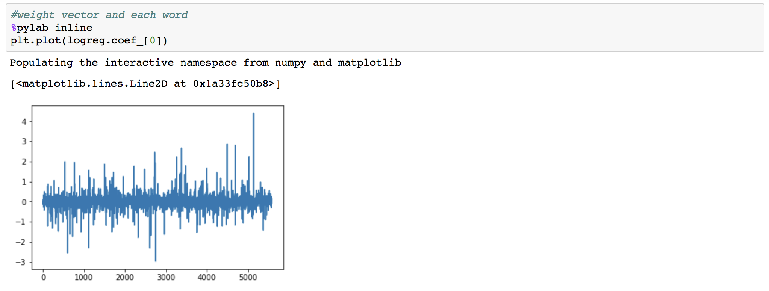

Given the graph, we thought it was a decent threshold value for finding positive words would be +2 and for negative words would be -2.

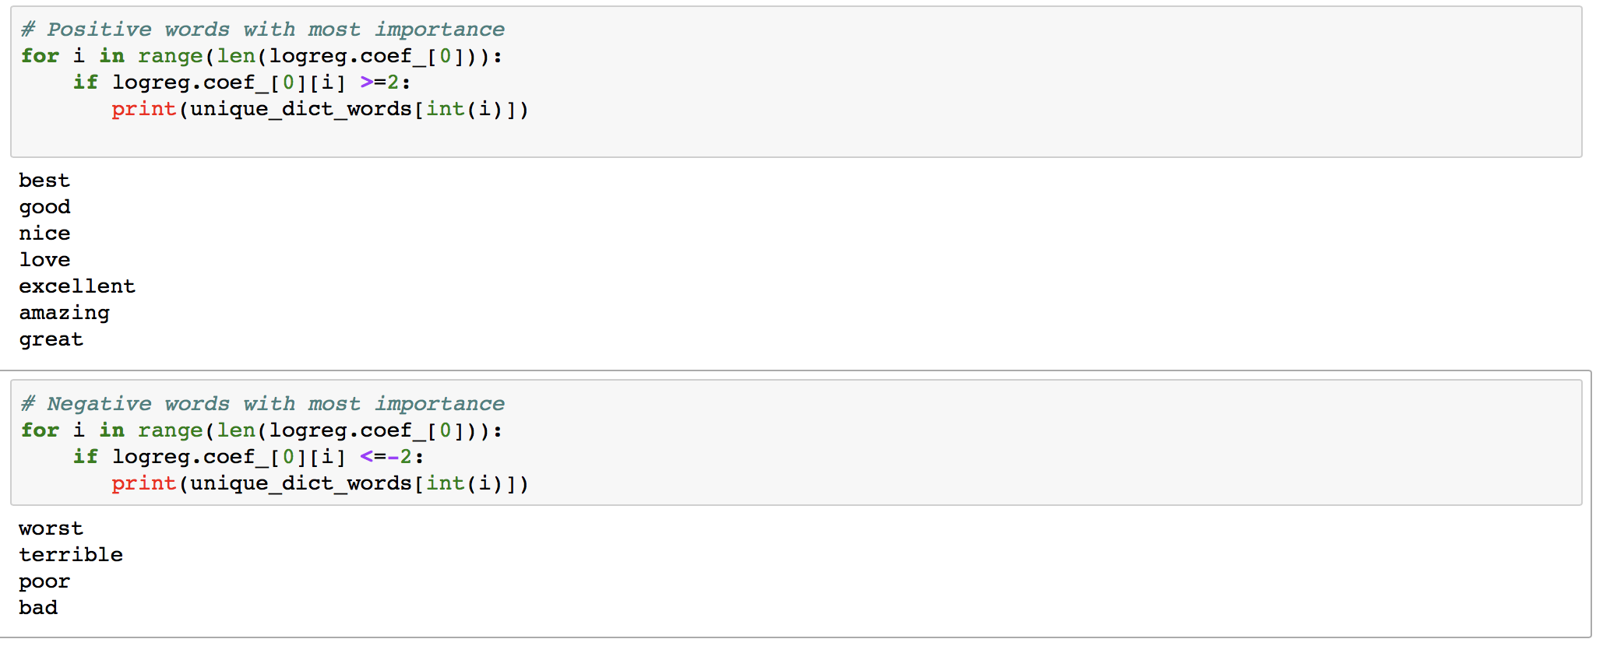

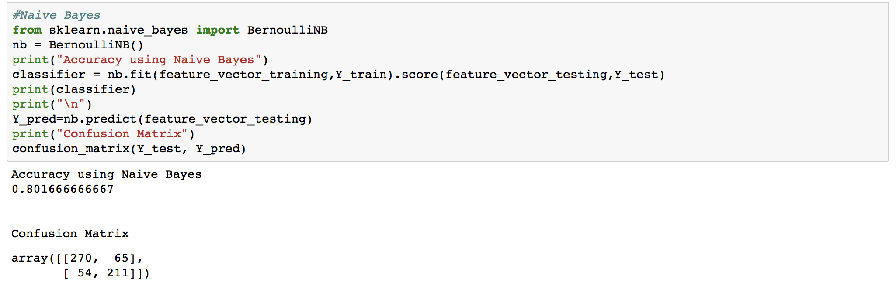

**Q1(g). N-gram model.** Similar to the bag of words model, but now you build up a dictionary of n- grams, which are contiguous sequences of words. For example, “Alice fell down the rabbit hole” would then map to the 2-grams sequence: ["Alice fell", "fell down", "down the", "the rabbit", "rabbit hole"], and all five of those symbols would be members of the n-gram dictio- nary. Try *n* = 2, repeat (d)-(g) and report your results.

**Ans1(g).** We created a new dictionary corresponding to n=2 and then repeated the steps above and predicted accuracy and found confusion matrix again with both logistic regression and naïve bayes model.

|  |  |
| --- | --- |
| LOGISTIC REGRESSION | NAÏVE BAYES |
| Accuracy- 0.548 | Accuracy – 0.546 |

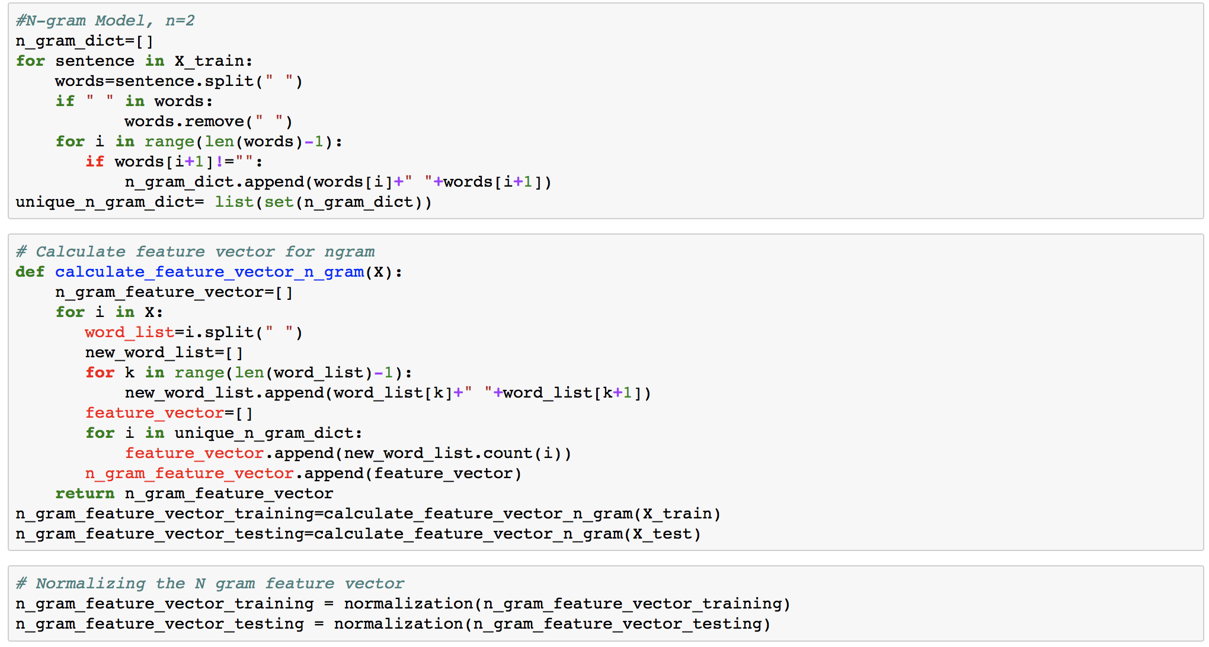

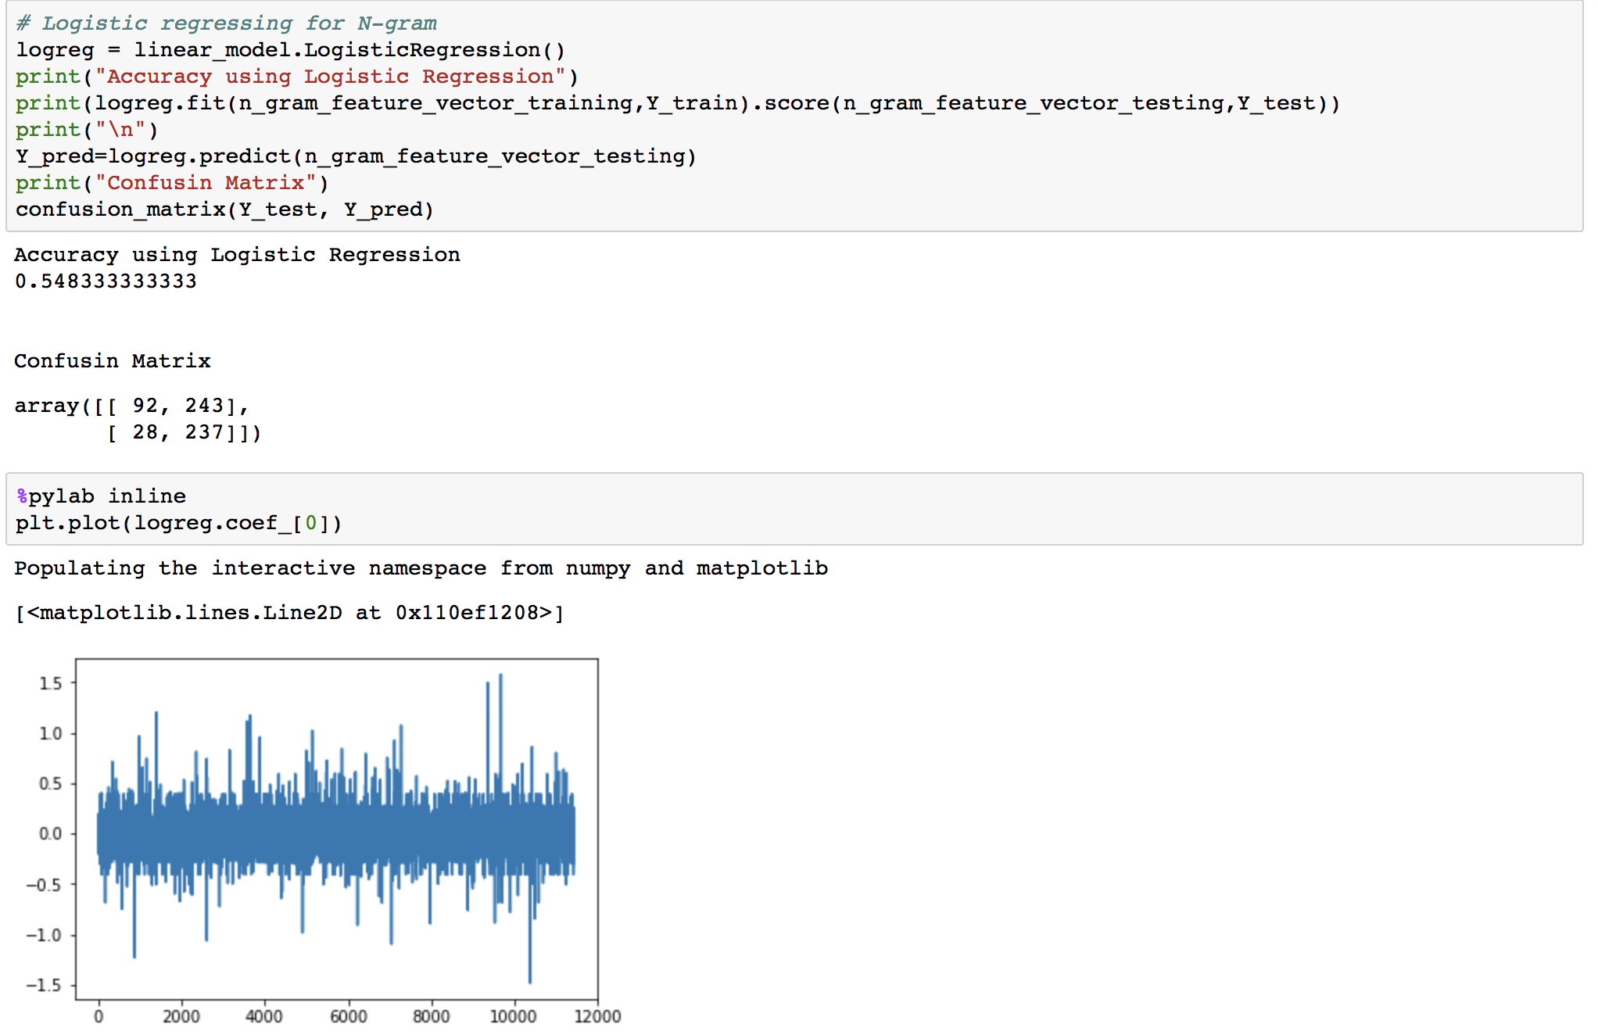

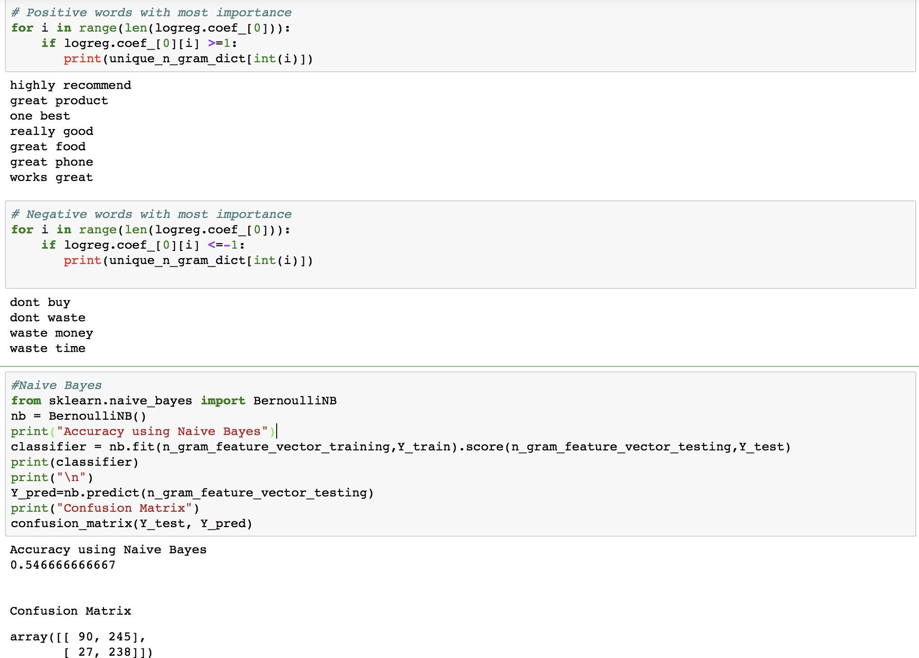

**Q1(h).** **PCA for bag of words model.** The features in the bag of words model have large redundancy. Implement PCA to reduce the dimension of features calculated in (e) to 10, 50 and 100 respectively. Using these lower-dimensional feature vectors and repeat (f), (g). Report corresponding clustering and classification results. (**Note:** You should implement PCA yourself, but you can use **numpy.svd** or some other SVD package. Feel free to double-check your PCA implementation against an existing one)

**Ans1(h).**

|  |  |  |
| --- | --- | --- |
| DIMENSIONS | LOGISTIC REGRESSION | NAÏVE BAYES |
| 10 | 0.5366 | 0.445 |
| 50 | 0.4966 | 0.4866 |
| 100 | 0.4866 | 0.4666 |

Variation of accuracy across classifiers upon changing dimensions.

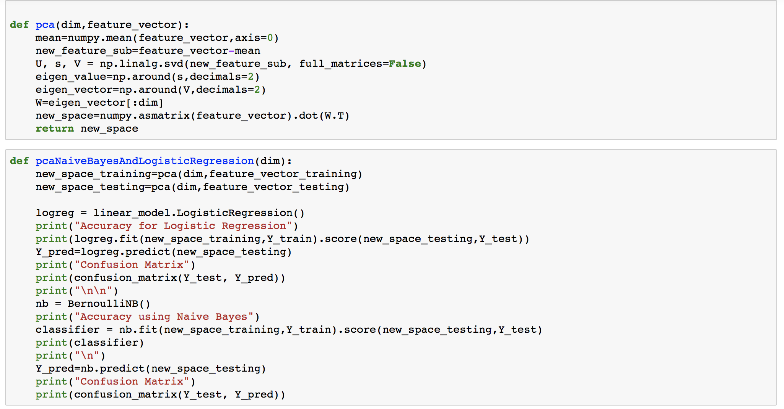

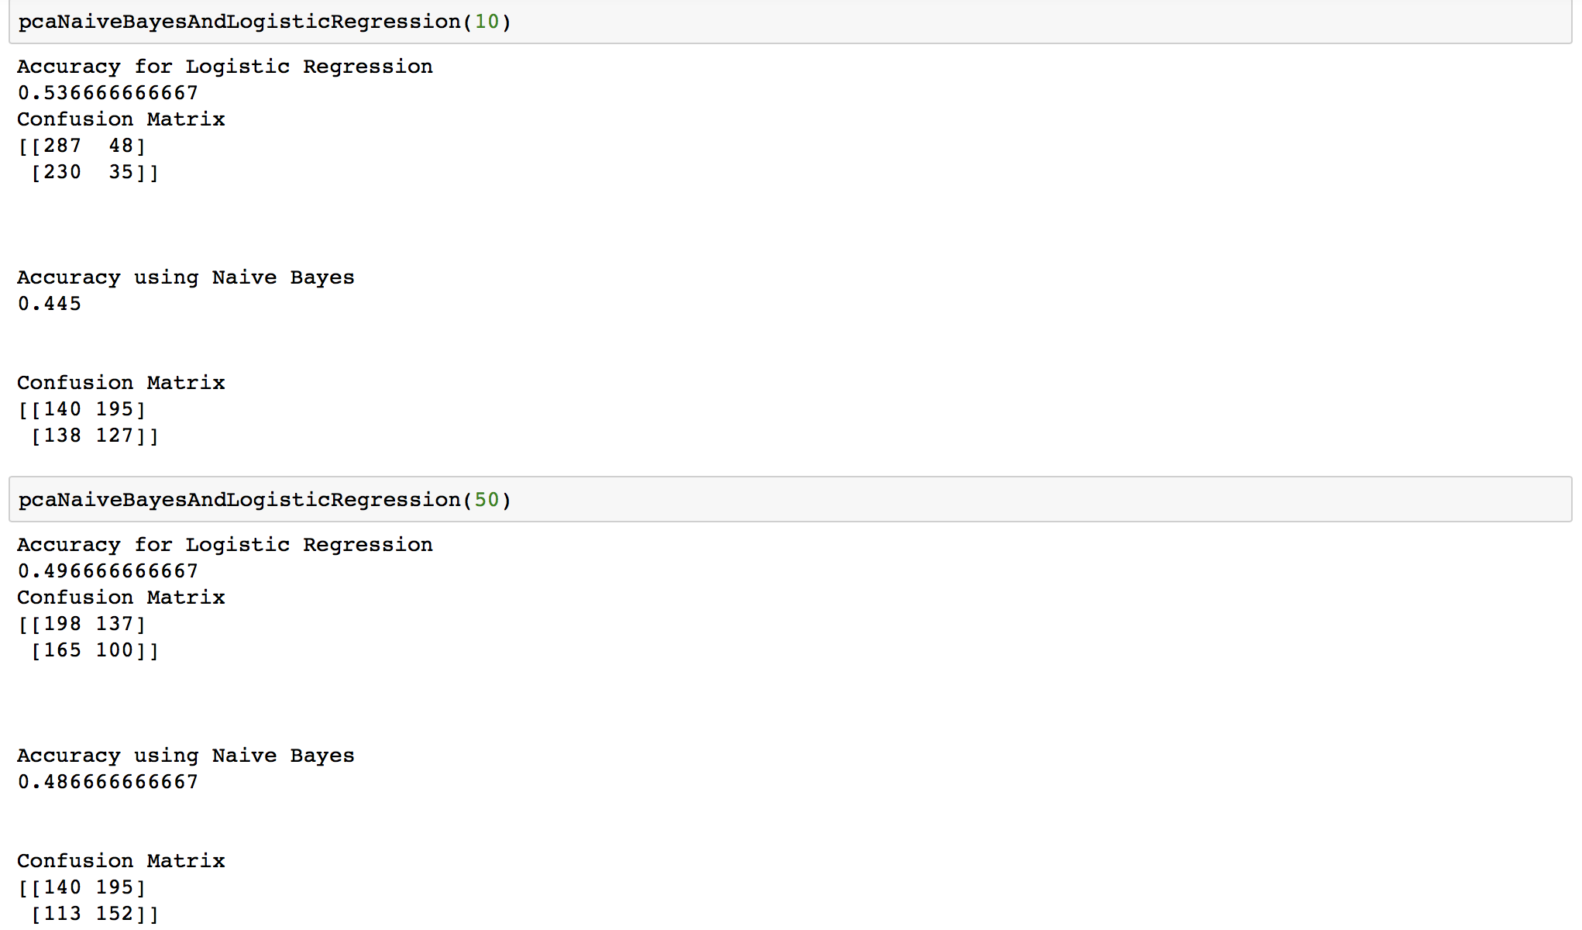

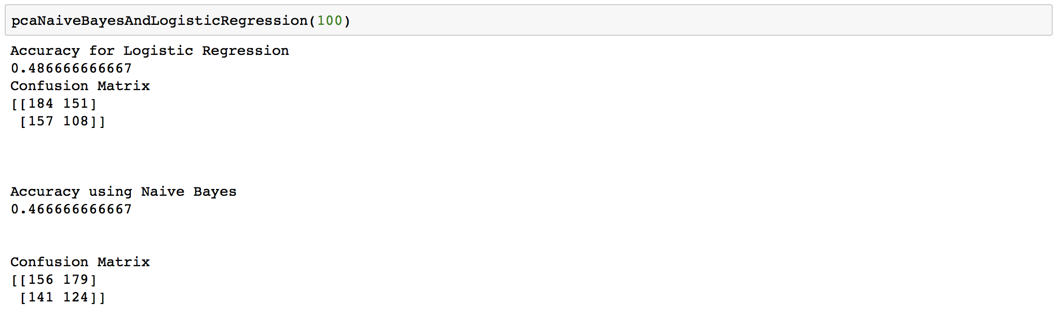

**Q1(i).  Algorithms comparison and analysis.** According to the above results, compare the perfor- mances of *bag of words*, *2-gram* and *PCA for bag of words*. Which method performs best in the prediction task and why? What do you learn about the language that people use in on- line reviews (e.g., expressions that will make the posts positive/negative)? *Hint:* Inspect the clustering results and the weights learned from logistic regression.

Ans1(i).

|  |  |  |
| --- | --- | --- |
| **Bag Of Words** | **2-Gram** | **PCA for Bag of Words** |
| Accuracy   * Logistic Regression – 0.79 * Naïve Bayes - 0.801 | Accuracy   * Logistic Regression-0.548 * Naïve Bayes - 0.546 | Accuracy   * Logistic Regression-0.537 * Naïve Bayes - 0.445 |
| Every word in the dictionary given a respective weight. | Every two word sequence in dictionary given a weight and therefore chances of the sequence repeating are less likely. | Given we only have 2400+600 data samples, reducing dimensions can result in reducing some valuable information that could have been used on test data, hence less accuracy. |

Therefore, it is clear that the best performance is achieved using ***BAG OF WORDS*** model.

On looking at the Logistic Regression result some specific words have the most weight in de-ciding the sentiment of a sentence. For eg. best

***Good, nice, love, excellent, amazing, great*** make the sentence positive whereas   
***worst, terrible, poor, bad***

make the sentence negative.

Similarly, 2-gram model suggests that:  
***highly recommend, great product, one best, really good, great food***

***great phone, works great*** - these phrases imply positive sentiment and

***dont buy, dont waste, waste money, waste time*** -these phrases imply negative

sentiments.

**Q2.** Clustering for Text Analysis

**Q2(a).** Analyze science2k-doc-word.npy using K-Means. Select a value for K. Give a rationale for why you chose a specific K, and find the closest 10 documents to each cluster. Comment on these results. What has the algorithm, captured? How might such an algorithm be useful?

**Ans2(a). Choosing a K:**There are many methods (Silhouette Coefficients, Elbow Method, V measure, and Homogeneity Score) to choose a good K in K-Means clustering. However, because of the nature of the dataset the first two methods don’t work well and the last two methods require a labeled dataset. Therefore, we plotted the data so we could visually inspect the data to choose a suitable K. In this two-dimensional representation of the data, it’s clear that 4 clusters can be identified. However, due to the dataset having thousands of features, its possible that this simple 2-dimensional representation of the data doesn’t sufficiently map the data. Therefore, we used PCA to preserve the data as much as possible while reducing the dimensions. However, we observed there either we cluster very well but lose most of the information of the data or we keep most of the information but cluster poorly.

Therefore, we decided to go with the original method of plotting the data, visually inspecting it, and choosing the K based on the number of clusters we can manually make out. In the case of the file ‘science2k-doc-word.npy,’ we chose a K of 4 based on the graph below:



**Closest 10 documents to each cluster:**

The algorithm has captured related groups of documents based on topic. For example, the first cluster has at least 6 titles based on the topic of biology, the second cluster has at least 7 titles based on the topic of science, the fourth cluster has 5 titles that start with ‘Corrections and Classifications’, etc. It was hard to find an overall theme for cluster 3, which leads me to believe that there was probably a more optimal K that could have been chosen instead of 4.

Regardless, this type of algorithm which groups/clusters documents together based on topic is useful in identifying similar batches of data for later use. For example, a media company might run K-Means on the titles of their articles and implement a new method of tagging to make it easier for users to search through past articles.

Closest 10 documents to Centroid # 1 are:

[[ '"Requirement of NAD and SIR2 for Life-Span Extension by Calorie Restriction in Saccharomyces Cerevisiae"']

[ '"Suppression of Mutations in Mitochondrial DNA by tRNAs Imported from the Cytoplasm"']

['"Thermal, Catalytic, Regiospecific Functionalization of Alkanes"']

['"Algorithmic Gladiators Vie for Digital Glory"']

[ '"Similar Requirements of a Plant Symbiont and a Mammalian Pathogen for Prolonged Intracellular Survival"']

['"Reopening the Darkest Chapter in German Science"']

['"Mothers Setting Boundaries"']

[ '"Distinct Classes of Yeast Promoters Revealed by Differential TAF Recruitment"']

['"Turning up the Heat on Histoplasma capsulatum"']

['"An Arresting Start for MAPK"']]

Closest 10 documents to Centroid # 2 are:

[['"Information Technology Takes a Different Tack"']

['"Algorithmic Gladiators Vie for Digital Glory"']

['"Reopening the Darkest Chapter in German Science"']

['"Archaeology in the Holy Land"']

['"Heretical Idea Faces Its Sternest Test"']

['"National Academy of Sciences Elects New Members"']

['"Baedeker\'s Guide, or Just Plain \'Trouble\'?"']

['"Science Survives in Breakthrough States"']

['"Vaccine Studies Stymied by Shortage of Animals"']

['"Divining Diet and Disease from DNA"']]

Closest 10 documents to Centroid # 3 are:

[['"The Formation of Chondrules at High Gas Pressures in the Solar Nebula"']

['"Algorithmic Gladiators Vie for Digital Glory"']

['"Reopening the Darkest Chapter in German Science"']

['"Heretical Idea Faces Its Sternest Test"']

['"Thermal, Catalytic, Regiospecific Functionalization of Alkanes"']

[ '"Corrections and Clarifications: A Short Fe-Fe Distance in Peroxodiferric Ferritin: Control of Fe Substrate versus Cofactor Decay?"']

['"Corrections and Clarifications: Unearthing Monuments of the Yarmukians"']

[ '"Corrections and Clarifications: Charon\'s First Detailed Spectra Hold Many Surprises"']

[ '"Population Dynamical Consequences of Climate Change for a Small Temperate Songbird"']

['"Nitric Acid Trihydrate (NAT) in Polar Stratospheric Clouds"']]

Closest 10 documents to Centroid # 4 are:

[['"Algorithmic Gladiators Vie for Digital Glory"']

['"Reopening the Darkest Chapter in German Science"']

['"National Academy of Sciences Elects New Members"']

[ '"Corrections and Clarifications: A Short Fe-Fe Distance in Peroxodiferric Ferritin: Control of Fe Substrate versus Cofactor Decay?"']

['"Corrections and Clarifications: Unearthing Monuments of the Yarmukians"']

[ '"Corrections and Clarifications: Charon\'s First Detailed Spectra Hold Many Surprises"']

['"Heretical Idea Faces Its Sternest Test"']

['"Archaeology in the Holy Land"']

[ '"Corrections and Clarifications: Uninterrupted MCM2-7 Function Required for DNA Replication Fork Progression"']

[ '"Corrections and Clarifications: Biotech Research Proves a Draw in Canada"']]

**Q2(b).** Analyze science2k-word-doc.npy using K-Means. Select a value for K. Give a rationale for why you chose a specific K, and find the closest 10 documents to each cluster. Comment on these results. What has the algorithm, captured? How might such an algorithm be useful?

**Ans2(b).**

**Choosing a K:**

There are many methods (Silhouette Coefficients, Elbow Method, V measure, and Homogeneity Score) to choose a good K in K-Means clustering. However, because of the nature of the dataset the first two methods don’t work well and the last two methods require a labeled dataset. Therefore, we plotted the data so we could visually inspect the data to choose a suitable K. In this two-dimensional representation of the data, its clear that 4 clusters can be identified. However, due to the dataset having thousands of features, its possible that this simple 2-dimensional representation of the data doesn’t sufficiently map the data. Therefore, we used PCA to preserve the data as much as possible while reducing the dimensions. However, we observed there either we cluster very well but lose most of the information of the data or we keep most of the information but cluster poorly.

Therefore we decided to go with the original method of plotting the data, visually inspecting it, and choosing the K based on the number of clusters we can manually make out. In the case of the file ‘science2k-word-doc.npy,’ we chose a K of 4 based on the graph below:



**Closest 10 documents to each cluster:**

The algorithm has captured related groups of terms based on how frequently it appears in documents. In other words, if a certain group of terms appears in the same documents together, they would be clustered together. Just looking at the results of the 10 closest terms to each cluster, it is hard to find a discernable theme binding the clusters together. This is in contrast from the results from clustering documents where it was easier to discern a theme running through each cluster – this is so because document titles have multiple words we can discern a theme from whereas terms are only one word, making it harder to analyze due to lack of information.

Regardless, this type of algorithm which groups/clusters terms together based on frequency in documents is useful in identifying which groups of terms are most often linked together.

Closest 10 terms to Centroid # 1 are:

[['hand']

['exhibit']

['cross']

['expressing']

['class']

['volume']

['able']

['transgenic']

['clock']

['detect']]

Closest 10 terms to Centroid # 2 are:

[['release']

['expressing']

['volume']

['fig']

['right']

['mediated']

['cells']

['width']

['obtained']

['land']]

Closest 10 terms to Centroid # 3 are:

[['tail']

['expressing']

['volume']

['right']

['cross']

['states']

['described']

['receptor']

['second']

['trend']]

Closest 10 terms to Centroid # 4 are:

[['expressing']

['volume']

['mediated']

['states']

['described']

['receptor']

['right']

['fig']

['compass']

['address']]

**Question 2**

**INSIGHTS**

* Clustering for text analysis can offer multiple ways to further analyze and categorize text. Clustering can unveil the relationships documents, terms, and other features have with one another. This could be an extremely powerful tool in the media, as there are many transcribed speeches or articles written on the internet.

**Q3.** EM algorithm and implementation

**Q3(a).** The parameters of Gaussian Mixture Model (GMM) can be estimated via the EM algorithm. Show that the alternating algorithm for *k*-means (in Lec. 11) is a special case of the EM algorithm and show the corresponding objective functions for E-step and M-step.

**Ans3(a).** A GMM is a probability distribution that consists of multiple probability distributions, in contrast to a normal Gaussian distribution which only has one. We fit a GMM with the Expectation-Maximization(EM) algorithm; EM algorithm is a series of steps to find good parameter estimates when there are latent (hidden or data that must be inferred) variables.

K-means is a special case of GMM which is demonstrated mathematically below:

K-means: find k to minimize ${(x-μ_{k})}^{2}$

Gaussian Mixture Model(EM clustering): find k to minimize $\frac{ {(x-μ_{k})}^{2}}{σ2}$

The difference (mathematically) is the denominator “ $σ^{2}$”, which means GM takes variance into consideration when it calculates the measurement. K-means only calculates conventional Euclidean distance without taking variance into account.

In other words, K-means calculate distance, while GM calculates “weighted” distance. This results in K-means being a case of “hard” clustering and GMM being a case of “soft” clustering.

K-means is a special case of GMM. This is shown as σ→0, the responsibility →1 for the cluster center closest to the target point, and the responsibility →0 for all other clusters. This is a "hard" assignment or K-means. Hence we have:

1. “E” step: assigning each point to a cluster. $y_{i}$ is the data input. $\hat{{γ }_{i}}$ is computed which indicates if cluster observation *i* belongs to cluster j or not by the binary values 1 and 0. The responsibility is computed as 1 if the data belongs to cluster j and 0 if not.

$\hat{{γ }_{i}}$ = 1 when argmin|| and 0 otherwise

1. “M” step: re-computing the cluster centers with weighted means and computed responsibilities
$$\frac{\sum_{i = 1}^{N}{(1-\hat{{γ }_{i}})y_{i}}}{\sum_{i = 1}^{N}{(1-\hat{{γ }_{i}})}}$$

2. Iterate steps 1 and 2 until convergence

**Q3(b).** Download the Old Faithful Geyser Dataset. The data file contains 272 observations of (*eruption time*, *waiting time*). Treat each entry as a 2 dimensional feature vector. Parse and plot all data points on 2-D plane.

**Ans3(b).**



**Q3(c).** Implement a bimodal GMM model to fit all data points using EM algorithm. Explain the reasoning behind your termination criteria. For this problem, we assume the covariance matrix is spherical (i.e., it has the form of æ2 *I* for scalar æ) and you can randomly initialize Gaussian parameters. For evaluation purposes, please submit the following figures:

* Plot the trajectories of two mean vectors in 2 dimensions (i.e. coordinates vs. iteration).
* Run your program for 50 times with different initial parameter guesses. Show the distribution of the total number of iterations needed for algorithm to converge.

**Ans3(c).**

**Termination Criteria:**

The EM algorithm terminated when the new likelihood converged to the old likelihood. We tested for this by setting a threshold of 0.01. If the absolute difference between the old and new likelihood was smaller than the threshold of 0.01, we considered it a convergence and terminated the algorithm.

**Trajectories of two mean vectors:**

Red indicated cluster 1 and Blue indicated cluster 2.



**Distribution of the total number of iterations needed for algorithm to converge:**

As seen, the GMM algorithm with random initializations usually needed between 5 to 10 iterations to converge.



**Q3(d).** Repeat the task in (c) but with the initial guesses of the parameters generated from the following process:

* + Run a *k*-means algorithm over all the data points with *K* = 2 and label each point with one of the two clusters.
  + Estimate the first guess of the mean and covariance matrices using maximum likelihood over the labeled data points. Compare the algorithm performances of (c) and (d).

**Ans3(d).**

**Trajectories of two mean vectors:**

Red indicates cluster 1 and Blue indicates cluster 2.



**Distribution of the total number of iterations needed for algorithm to converge:**

As seen, the GMM algorithm with K-Means initializations usually needed between 5 to 10 iterations to converge.



**Comparing the algorithm performances of GMM initialization and K-Means initialization:**

Pre-clustering via K-Means helps accelerate convergence. This is seen when comparing the trajectories of the mean vectors of GMM initialization and K-Means initialization as well as the distributions of total iterations. K-means needs less iterations to converge as well as the initial clusters are more accurate than the random clusters given by GMM initialization.

**Question 3**

**INSIGHTS**

* K-means only slightly improves on the GMM in needing less iterations – this is probably due to the fact that the Old Faithful Geyser Data is already a well parsed, and easily clustered dataset. In more difficult or ambiguous datasets, K-Means effectiveness would probably exponentially increase.

**WRITTEN EXCERCISES**

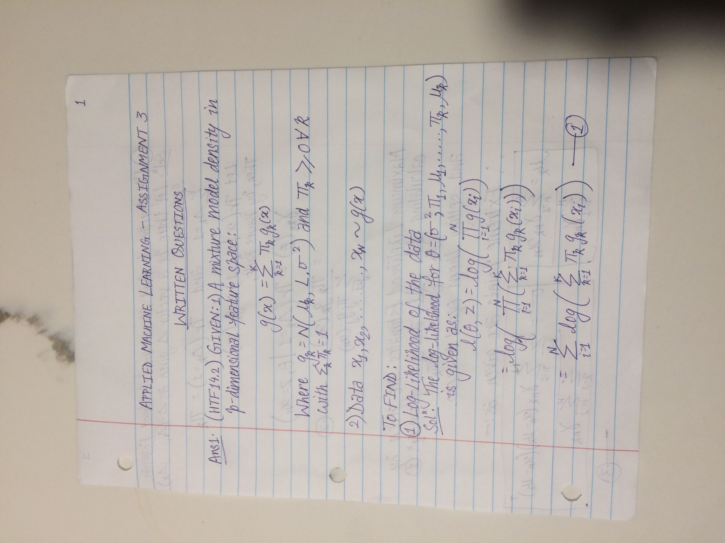

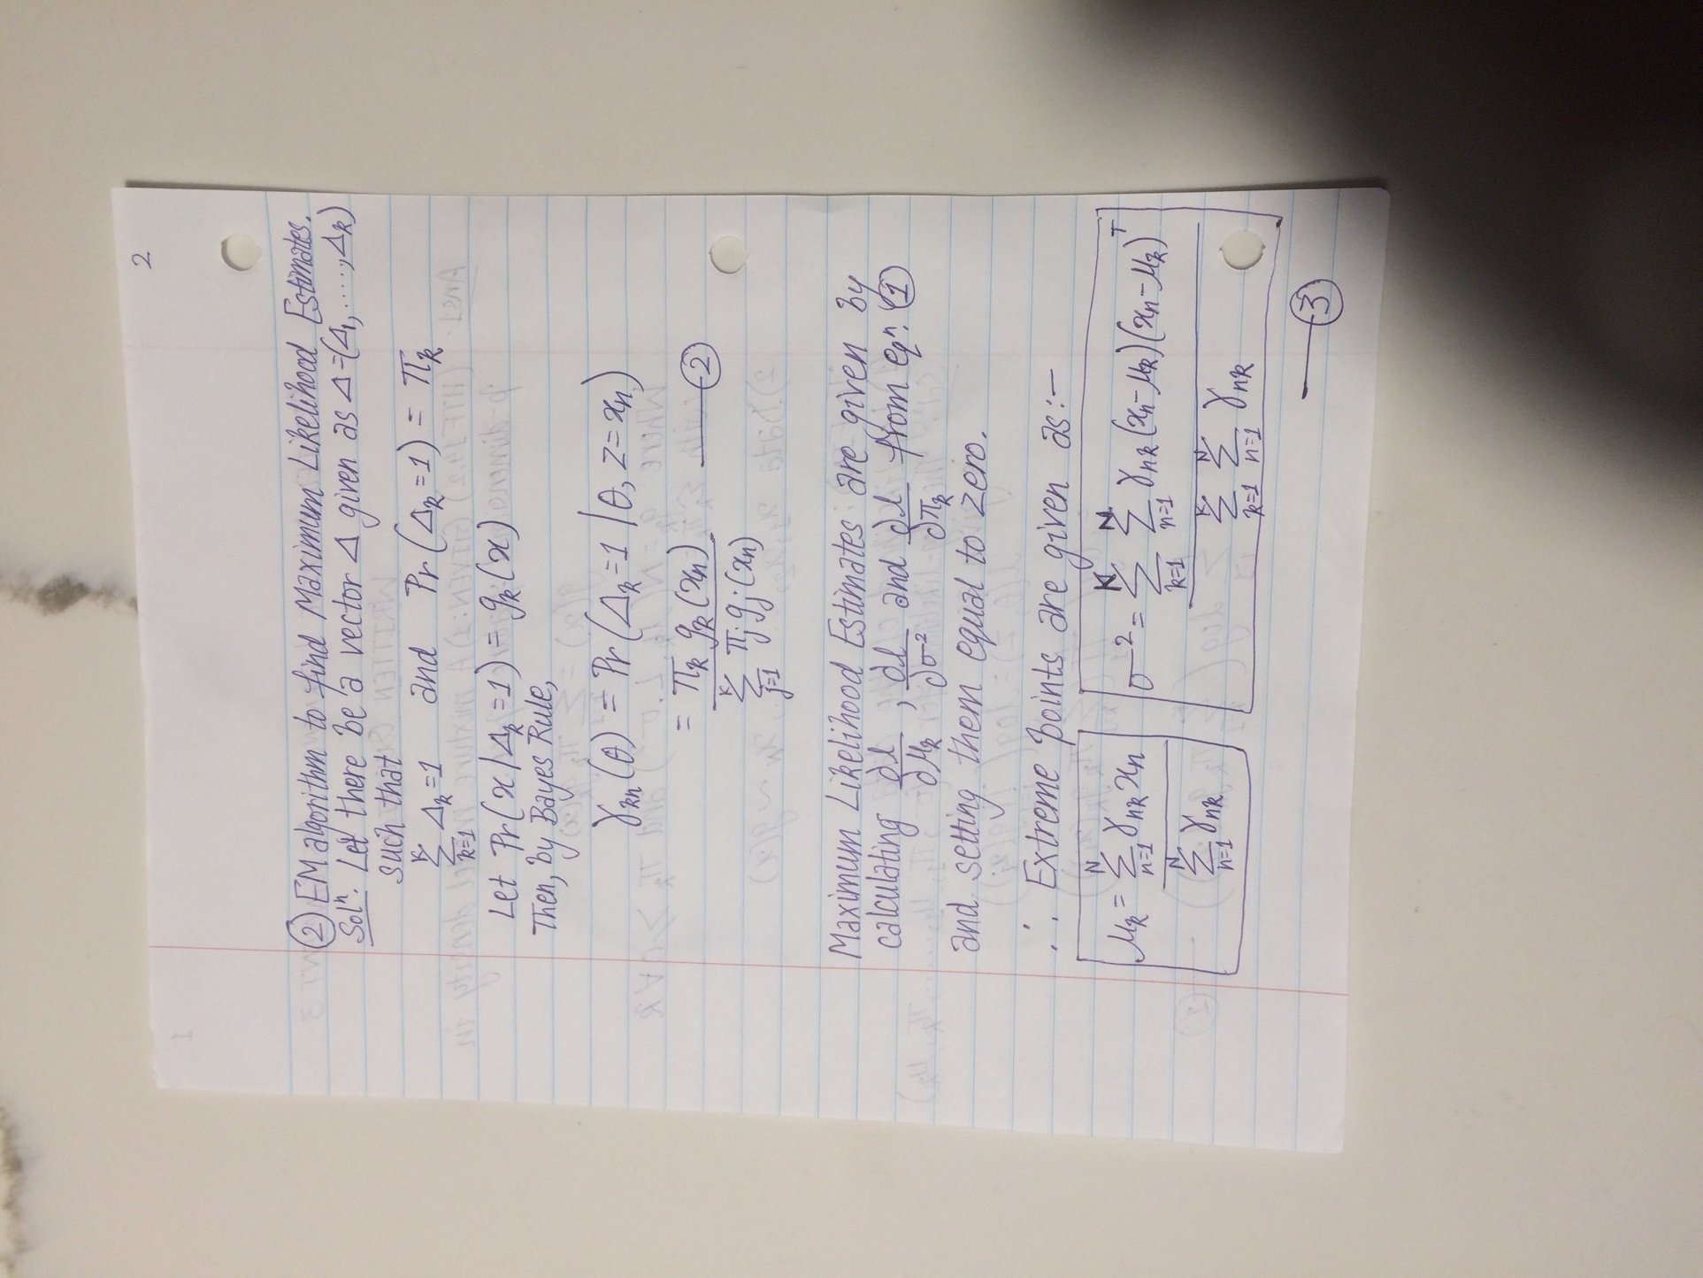

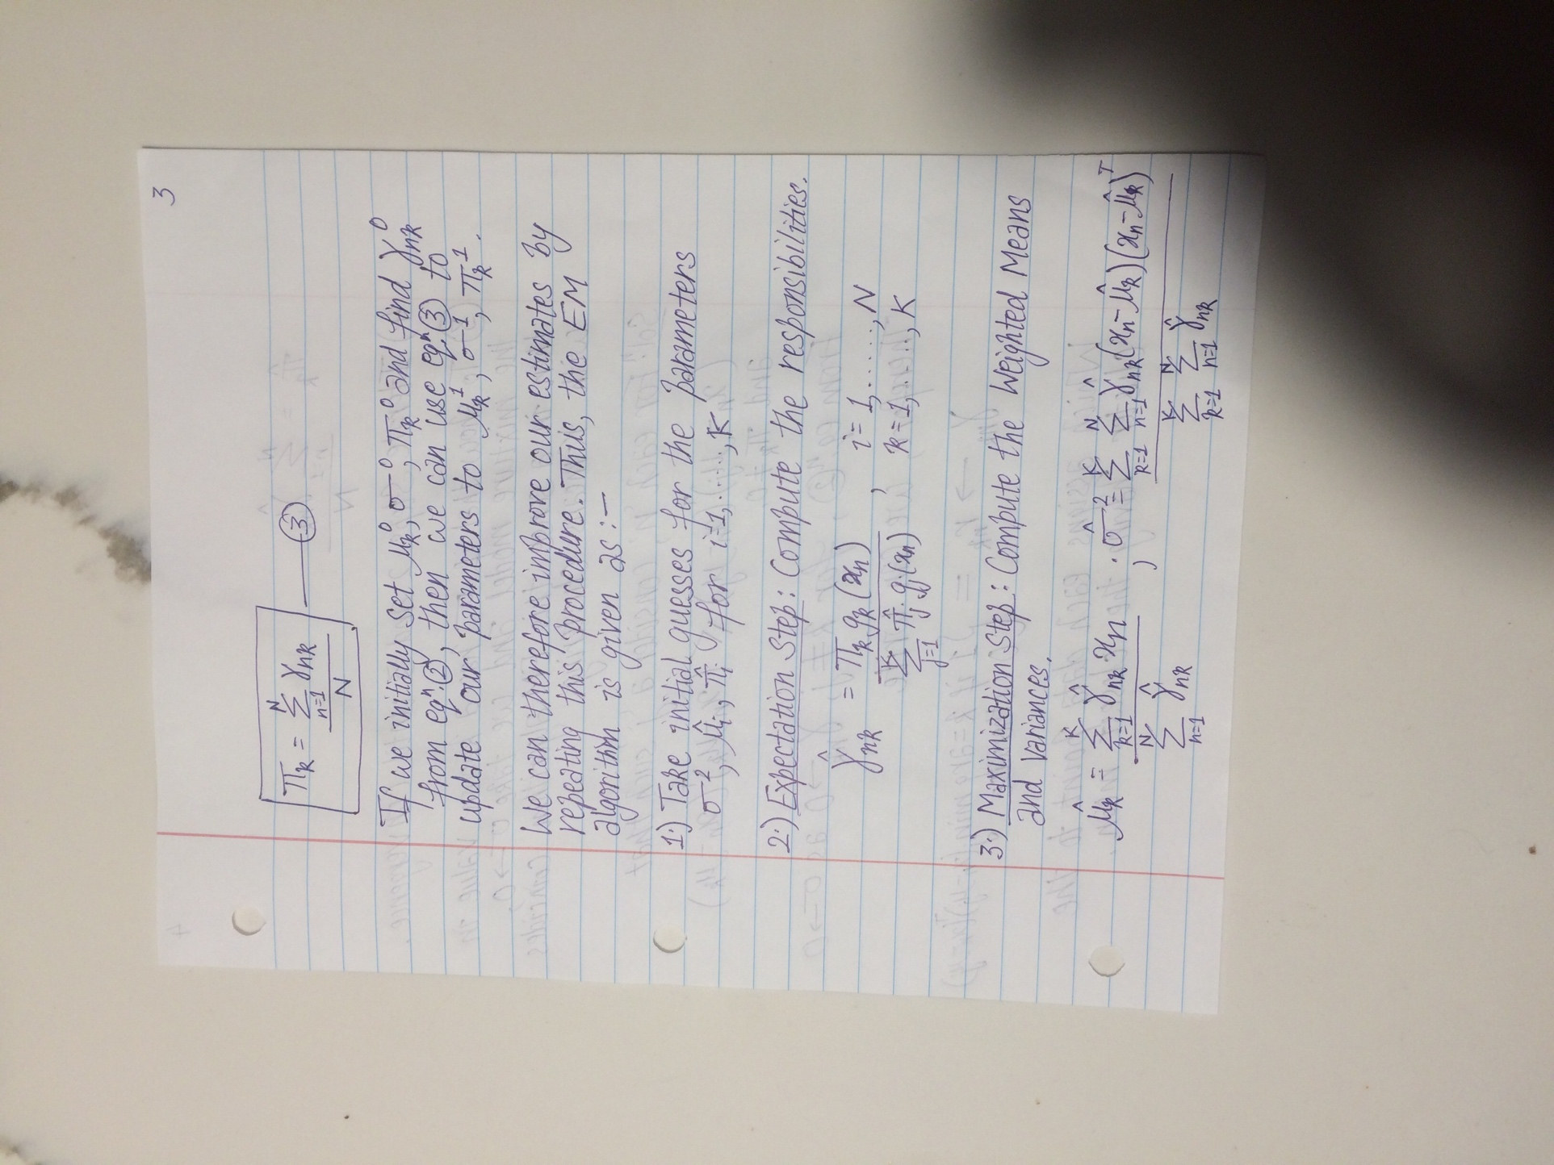

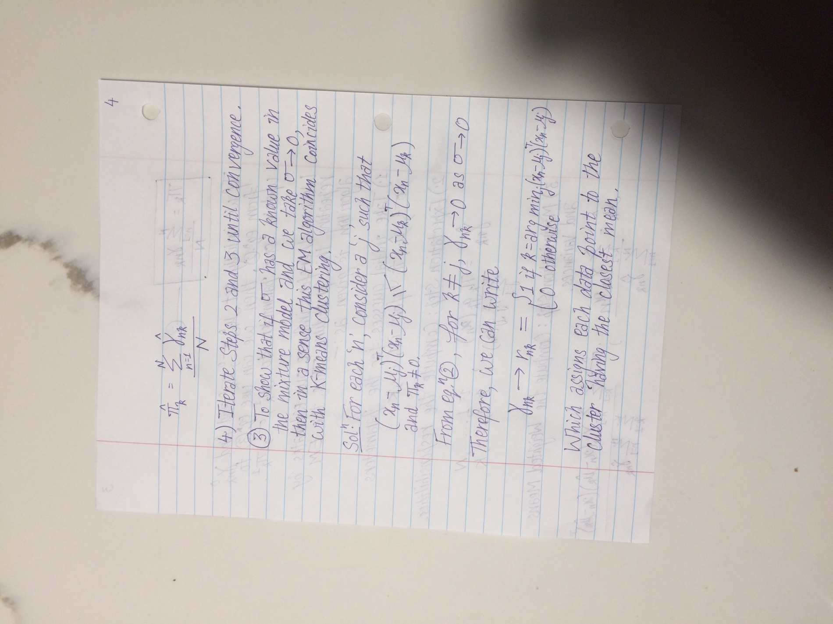

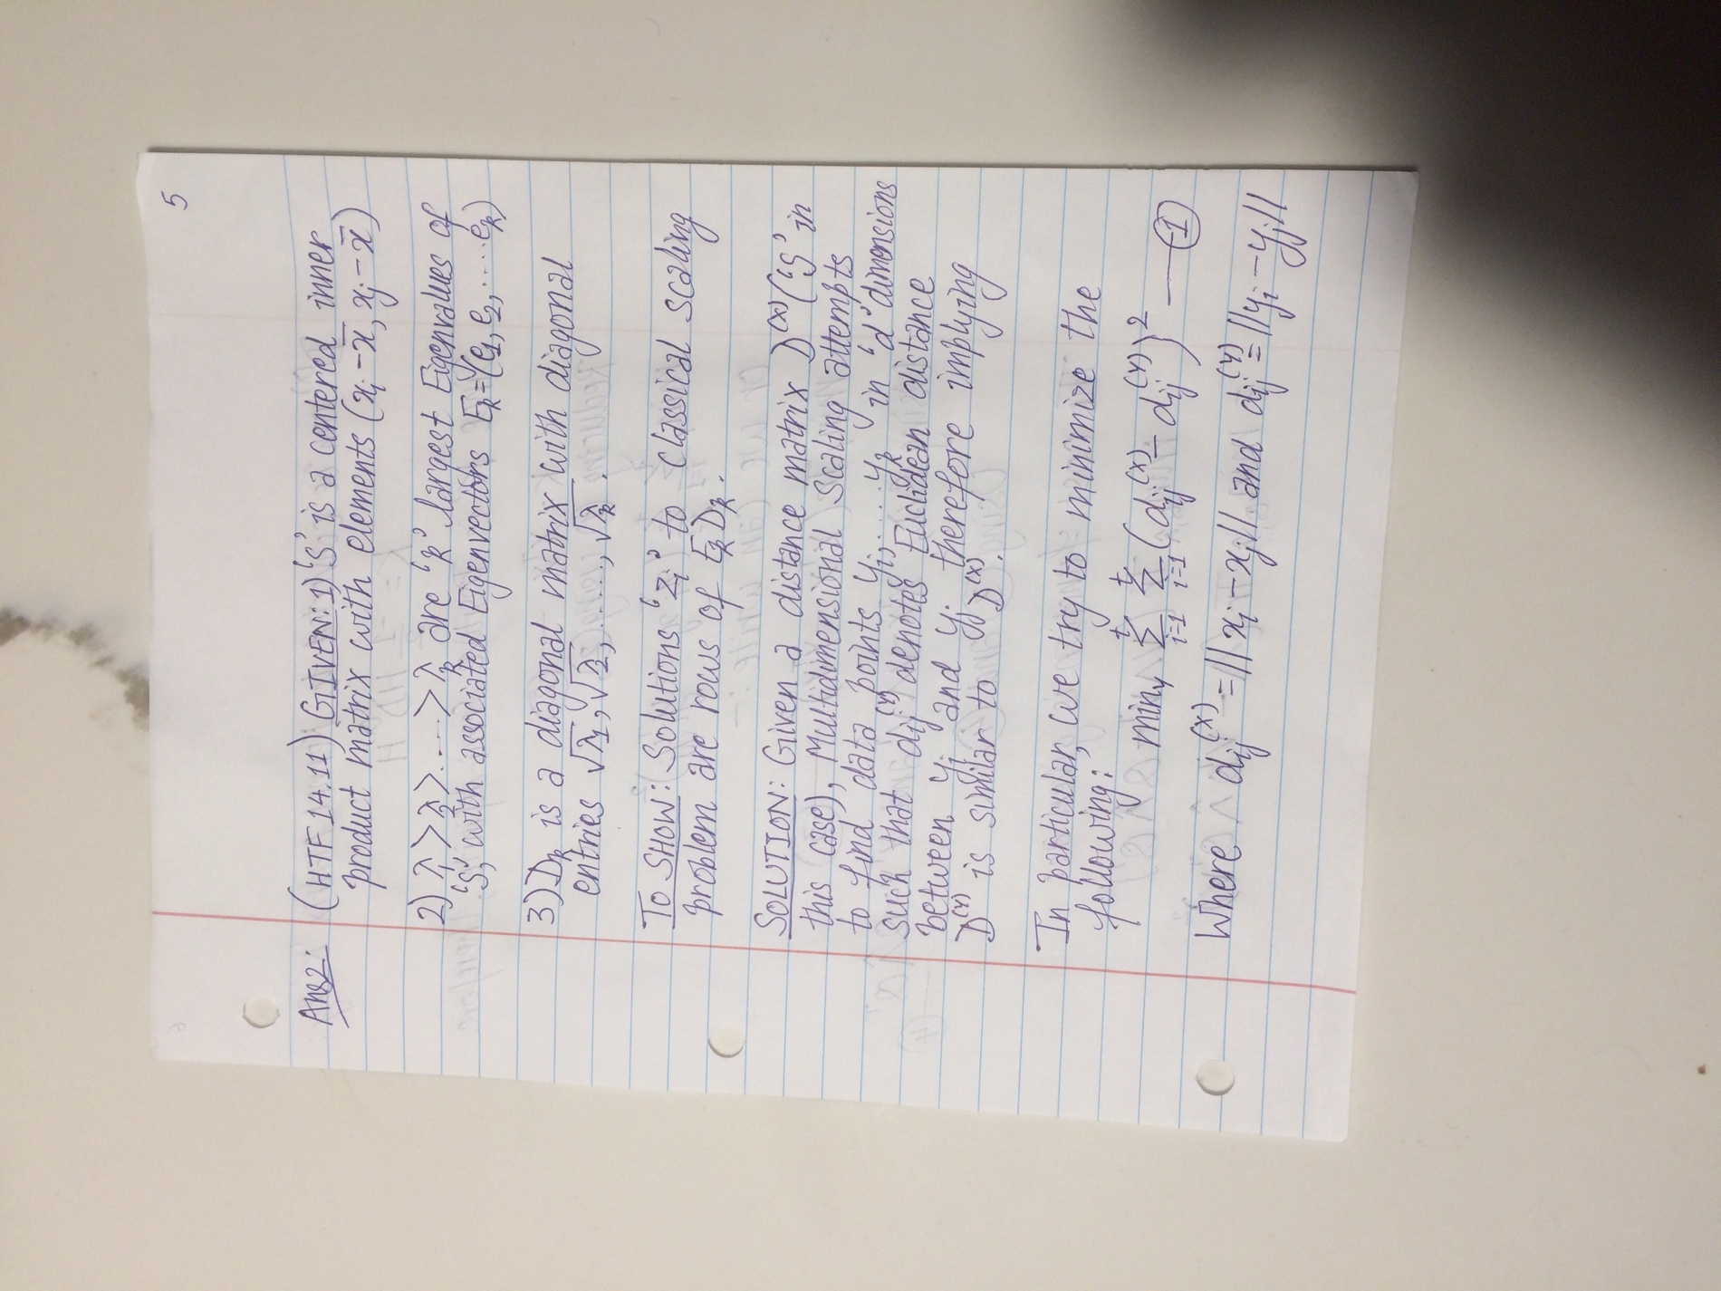

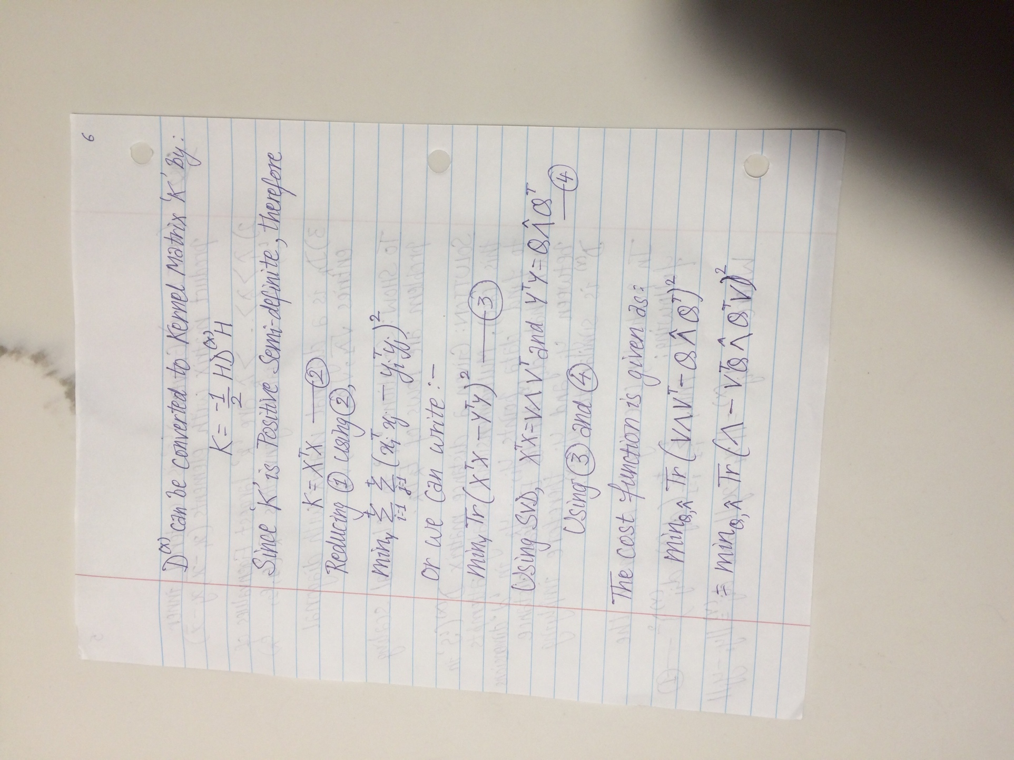

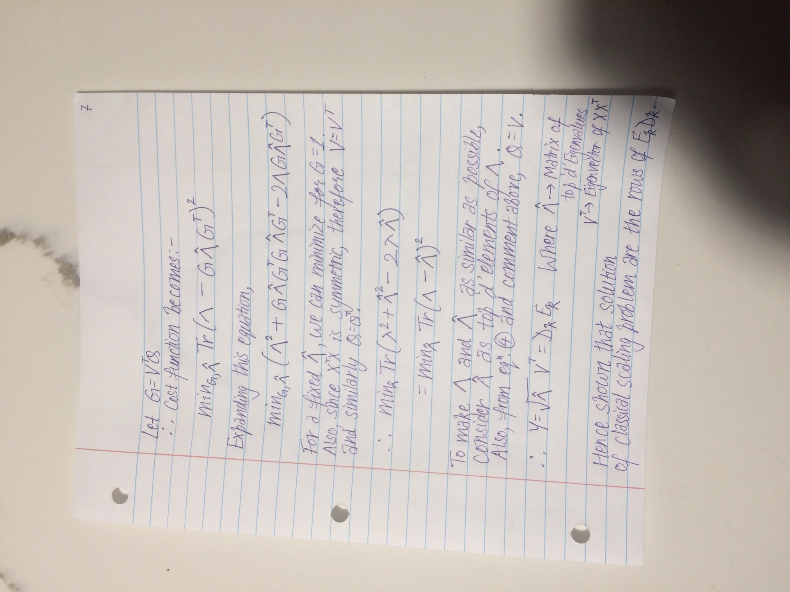

**Ans3.)**



